1. Create ConfgMap or MongoDB EndPoint. ( The MondoDB sevice name)

DB_URL:mongo-service

name of clusterIP service attached to db-deployment

**apiVersion**: v1

**kind**: ConfigMap

**metadata**:

**name**: mongodb-configmap

**data**:

**DB_URL: mongo-service**

**clusterIp_name: mongo-svc**

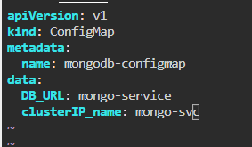

1. Create A secret or MongoDB User & PWD

USER_NAME: mongouser

USER_PWD: mongopassword

**apiVersion**: v1

**kind**: Secret

**metadata**:

**name**: mongo-secret

**data**:

**DB_URL: mongo-service**

**clusterIp_name: mongo-svc**

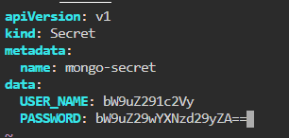

3 Create MongoDB Deployment Applicaton with Internal service (ClusterIp) Mongo DB needs

username + password to operate

Vars needed in mongoDB:

MONGO_INITDB_ROOT_USERNAME: root

MONGO_INITDB_ROOT_PASSWORD: example

Deployment

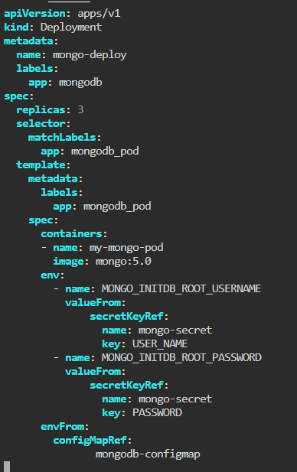

Service

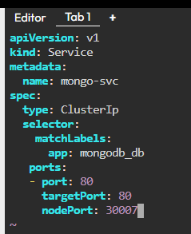

4 Create webApp Deployment(FrontEnd( with external service) and it needs to access MongoDb,

so it needs username+ password + mongodb endpoint (mongodb service) container runs on

3000

Webapp deployment

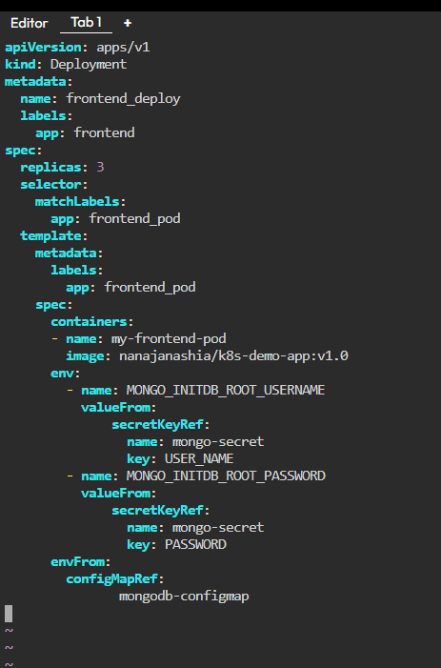

Webapp service

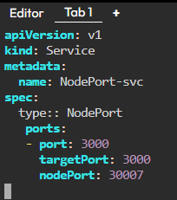

8- How many Nodes exist on the system?



9- Do you see any taints on master ? no



10- Apply a label color=blue to the master node



11- Create a new deployment named blue with the nginx image and 3 replicas

Set Node Afnity to the deployment to place the pods on master only

NodeAfnity: requiredDuringSchedulingIgnoredDuringExecuton

Key: color

values: blue





12- Create a taint on node01 with key o spray, value o mortein and efect o

NoSchedule



13- Create a new pod with the NGINX image, and Pod name as

Mosquito



14- What is the state o the mosquito POD? Pending



15- Create another pod named bee with the NGINX image, which has a toleraton set to

the taint Mortein

Image name: nginx

Key: spray

Value: mortein

Efect: NoSchedule

Status: Running

